PRESS RELEASE: For Immediate Release

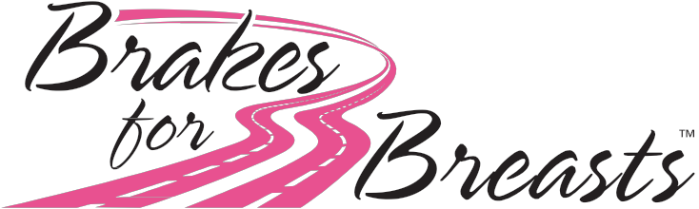

Contact: <YOUR NAME>
<YOUR PHONE>
<YOUR EMAIL>
www.brakesforbreasts.org

Celebrating Ten Years of Putting the Brakes on Breast Cancer!
Throughout October automotive repair shops across the country are looking to end breast cancer with a unique fundraising campaign.

During the Month of October, <SHOP NAME> in <CITY STATE> and hundreds of Independent Auto Repair Shops across the US are raising funds for a breast cancer vaccine as part of the Brakes for Breast fundraiser.

As part of the fundraiser, the auto repair facilities are giving away FREE (quality) brake pads or shoes. The customer simply pays the labor and any other ancillary parts necessary to complete the brake job and the shops then donate 10% of the brake job directly to Dr. Vincent Tuohy & the Cleveland Clinic Breast Cancer Vaccine Research Fund.

100% of what we donate goes directly to research! Celebrating our 10th year and $1,000,000.00!

2020 marks the tenth year for the Brakes For Breasts fundraiser.
2011 Our 1st year - 5 shops in Ohio raised $10,000
2012 Our 2nd year - 27 shops in 17 states raised $32,848
2013 Our 3rd year - 66 independent auto repair shops in 27 states raised $66,499
2014 Our 4th year – 143 independent auto repair shops in 29 states raised $115,236.53
2015 Our 5th year – 174 independent auto repair shops in 32 states raised $141,868
2016 Our 6th year - 131 independent auto repair shops in 35 states (most ever!) $125,867.37
2017 Our 7th year - 114 independent auto repair shops in 34 states raised $114,389.20
2018 Our 8th year – 138 independent auto repair shops in 34 states and 2 countries raised $141,061.80
2019 Our 9th year – 141 independent auto repair shops in 38 states and 2 countries raised $194,160.04

To date donation total is $940,931.74!

This Brakes For Breasts fundraiser is different from any other breast cancer fundraising campaigns:
- Dr. Tuohy at the Cleveland Clinic has actually created a vaccine that has proved effective in laboratory animals in actually preventing breast cancer. Think about Polio, eradicated because of a vaccine, a distant memory for most generations. This is the same principle!
- Dr. Tuohy and his team are rounding the corner and are hoping to start Phase 1 trials in early 2021.
- 100% of the proceeds from the ‘Brakes for Breasts’ fundraiser goes directly to the Cleveland Clinic for research on the Breast Cancer Vaccine.
- These are just “mom & pop” shops across the country, independent business owners that have joined hands for a great cause.

For more information about the Breast Cancer Vaccine, Dr. Tuohy and a list of participating shops go to www.brakesforbreasts.com or follow us on Facebook!

About <YOUR SHOP NAME>:
<YOUR SHOP NAME> is a locally-owned auto repair shop in <CITY, STATE>. Owner <OWNER NAME> and his team are dedicated to premier service, customer education, and community service. More information is available on the company’s website: <YOUR COMPANY WEBSITE>

